Facilities Maintenance Request User Guide
Contents
Where do I start? 1
How do I make a maintenance request? 1
How do I complete the form? 1
How to ask a question about or provide additional information for a request I already submitted? 2
How do I change email notifications about my requests? 3
How do I check the status of my maintenance request? 4
Who do I contact if I have questions about maintenance requests? 5

Where do I start?
Navigate to Facilities Maintenance Request home screen: https://radford.assetworks.cloud/ready
Log in SSO, then after log in you will see the dashboard menu bellow
List of all Tiles
Carpentry | Electrical
Housekeeping | HVAC
Pest Control | Plumbing
Emergency Systems | Environmental Health & Safety
Residential Furniture

How do I make a maintenance request?
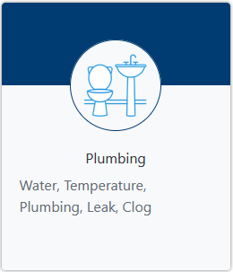
On the Home screen, select the tile that corresponds with your maintenance need OR search for your issue. For example, if you notice the water fountain in a university owned building isn’t working, then choose the Plumbing tile or search “water fountain”.

Form will populate your info after logging in SSO verification and all required fields are notated with RED( *)
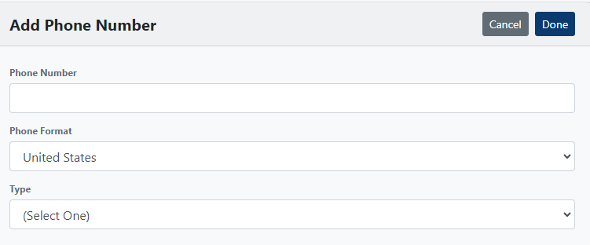
PRO TIP: Add your phone number to your User Profile so that it will display on all future requests.
Select Settings, then User Profile
Scroll to Phone box and select Add button
Type in phone number (including area code)
Select Done

Ho do I complete the form?
In the box that says, “If there are multiple rooms, or if floor/room is not listed, enter information below.,” enter any additional location description that will assist with locating the issue as in the image below.
Note: If you’re making a request for maintenance in a Residential Building, then you will be prompted to select information about permissions, animals, and availability.
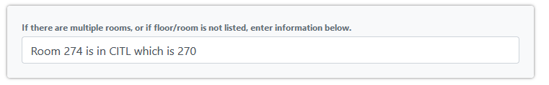
*Please give your best times when you are available during business hours*

Once you have completed the form, proceed with selecting the Next button to continue.
If you select Next, you’re then given an opportunity to provide additional information. This is where you may state anything that hasn’t already been previously selected as a choice.
Select the Next button to continue. Select the Previous button if information needs to be corrected. Select the Cancel button to clear the form and start over on the Home screen.

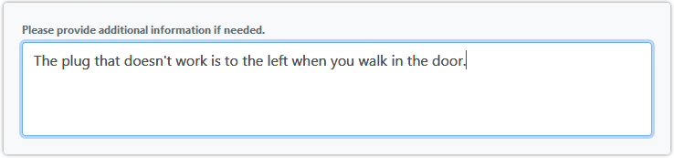

On the next screen, you may attach a photo or document that helps explain the issue. This is optional. Drag and drop files or select the Browse button to locate files on your computer to attach to your request.
NOTE: Apple live photo format –HEIC—is not supported.
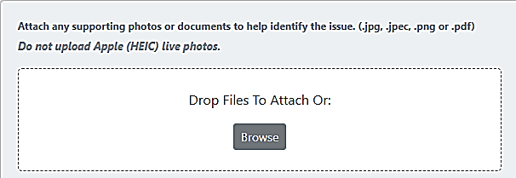
The attachments field is the last field of the form. Select the Review button to review the information you’ve entered before submitting.

After reviewing all the information you’ve provided, if you need to edit the information, select the Previous button until you reach the screen where you need to edit. If the information is correct, select the Submit button. Selecting the Cancel button will clear the form and take you back to the Home screen to start over.

How to ask a question about or provide additional information for a request I already submitted?
From the Home screen, select the Process button on the navigation bar.
On the Process screen menu, select Your Open Requests and then navigate to your request that you need to edit.
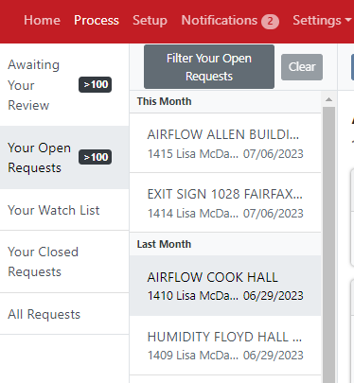
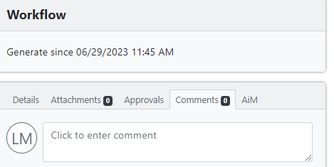
Select the Comments tab and type your comments in the field. You can direct your comment to a specific person by using the “@” symbol and their user name. Example: @jpdoe. Then hit Enter on your keyboard.

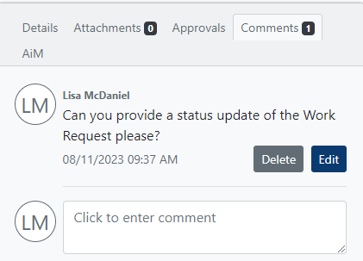

How do I change email notifications about my requests?
From the Home screen, go to Settings and then User Profile.
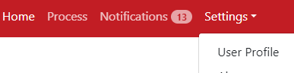
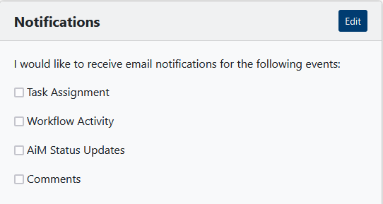
From your User Profile menu select Notifications and then click Edit button in the top right corner.

Then select the events for which you would like to receive email notifications. These are the events to choose from:
- Task Assignments – email informing the user if they are required to acknowledge or approve a task. (Not common)
- Workflow Activity – email informing the user that an action has been taken. There is no action required from the user, it is just informational. Also, the history will be present at the bottom of the request.
- AiM Status Updates – email informing user that request has been accepted and a Work Order has been created.
- Comments – email showing the user what comments have been added.

You will not receive notifications for the events that are unchecked.
When you have finished selecting or unchecking notifications, select the Done.
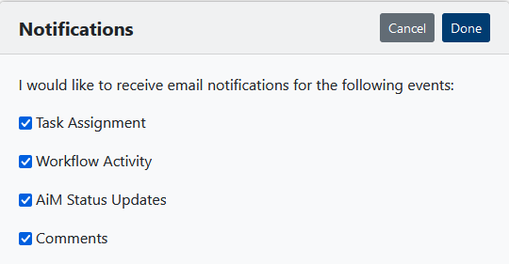
NOTE: If you turn off email notifications, you are responsible for logging in to check your open requests for any action required.

How do I check the status of my maintenance request?
After you have submitted your request, you can check the status of it to see if a Work Order has been created or if there is more information needed. From the Home screen, select Process in the navigation bar, and then select Your Open Requests. Select the request you want to know about.
Then select the AiM tab. Under Records, if you do not see anything, this means that a Work Order has not been created or has been routed for approval.
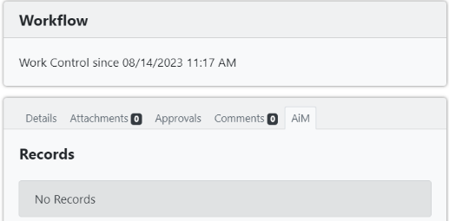

Once a work order is created, you will see a work order number (e.g., Work Order: 24-01372) and its status (e.g., OPEN) as well as a Shop Phase. If you call facilities about your request, please reference your work order number or request #.
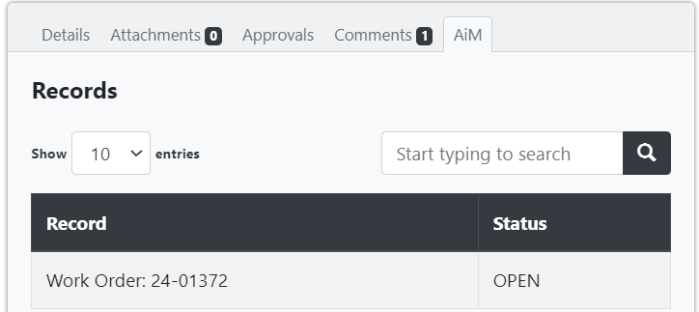
You can also click on the Approvals tab and get a timestamp of when the work order was created. This is also where the approval tab shows the responsibility work-flow.
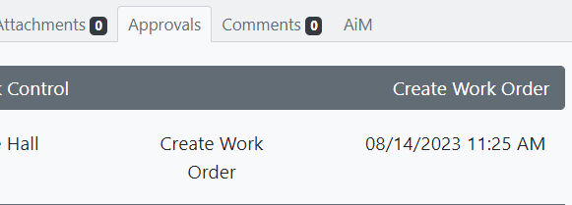
Note: If submitting a Student Residential Furniture request the work-flow will show Work Control sending the responsibility to be completed by Res-Life.

Other Work-flow how-tos

Who do I contact if I have questions about maintenance requests?
For questions about maintenance requests, contact Facilities Maintenance and Operations at 540-831-7800 or facilities@radford.edu.

